MPA 634  
Data Science for Managers  
Final Exam: Fall 2019

# Definitions and Concepts

1. First explain distribution of a random variable, then define each of the four characteristics of a distribution, and finally detail how you measure and detect each of the four characteristics.  
     
   Distribution:

* The possible values for the random variable
* Probability or frequency of observation

Location

* Central tendency
* Mean and Median

Scale

* Spread
* Standard deviation and IQR

Symmetry

* Skewness
* Relationship of mean and median
* Location of median in the box part of a boxplot
* Length of whiskers

Outliers

* Deviant or extreme observations
* z-scores
* Greater than 1.5 IQR from the hinges of the boxplot

1. Explain the difference between hypothesis generation and hypothesis confirmation. How is this concept related to training and testing sets?

Each observation can be used for exploration or confirmation, but not both.

You can use an observation as many times as you want in exploration but only once in hypothesis confirmation. As soon as an observation gets used more than once, we have transitioned from confirmation to exploration.  
  
We can separate our data into training sets and testing sets. This way we can use our training set data as many times as we want when exploring our data.

We then use the resulting model to test the accuracy of our model once on the testing set.

A new practice is to create a query set to test our training set repeatedly before we do the final, one test using the testing set.

1. Define factors and then explain how they are related to order and level. Use an example to illustrate your answer.

Factor variables usually can have a fixed and known set of values. Factor variables can be represented as characters and integers. An example of a factor would be the grades that are awarded in a class.

Factors are preferred when a character variable has a reasonably small number of values. Each category in a factor is called a level. Factors have the advantage that they can be ordered.

Factors allow character information to be stored very efficiently on a computer. Each level of a factor can be assigned a code. The code for each observation can then be efficiently substituted for an entire string. Factors are also helpful when we are trying to find data entry errors.

1. Carefully define residuals and then explain how they are related to the idea of explained and unexplained variation.  
     
   Residuals are the difference between the actual value and the predicted value.

For each observation, the predicted value is the part that is explained. The residual is the part that is not explained by the model.

The total variation in a variable can be separated into the pattern or that which is explained by the model and the residual which is that part which isn’t explained by the model.

1. Explain why a tibble is a list but not all lists are tibbles.

In R, vectors are one dimensional holders of information. Vectors have slots or positions in which information and be stored. The information can be referenced by specifying its slot number or name. Although not everyone agrees with Hadley Wickham, he states that there are two kinds of vectors:

* atomic vectors
* lists or recursive vectors

In most programming languages, lists are heterogeneous. This means that they can hold information of a variety of different classes: logical, integer, double, character, etc. The objects in a list can also have a variety of lengths. Lists can even contain other lists. Using lists within lists is a common practice.

A tibble is a collection of atomic vectors that are arranged in a list. Each of the atomic vectors must have the same length in a tibble. This means that tibbles are rectangular lists. This means that a tibble is a special case of a list.

# Line by Line Code Interpretation

Please explain the following code chunks. By referring to line numbers, carefully explain the code and describe what it is accomplishing. Please avoid just repeating the R commands that are in the code.

Code Chunk 1: Pareto Charts

Here are two alternative ways to create Pareto charts. Please explain each line of code and then compare and contrast the two different approaches to creating Pareto charts.

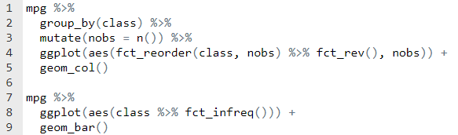

Lines 1 – 2: Divides the tibble mpg into groups by the class of the vehicle  
Line 3: Counts the number of observations in each class and creates a new variable called nobs  
Line 4: Receives the tibble created in lines 1 – 3. It identifies the class variable in the aesthetic statement. It reorders the factor levels of class based on the number of observations. The order is from smallest to largest initially but the fct_rev() changes that so that the factors levels are ordered from largest to smallest.  
Line 5: Because we have already counted the number of observations for each class, we use geom_col to put the only layer on our graph, which is a bar chart.

Lines 7 – 9: Identifies mpg as the data source and pipes it into ggplot. The aes identifies the factor class as the x-variable and then reorders the factor levels based on their frequency using fct_infreq(). The factor levels are ordered from largest number of observations to smallest number of observations.  
Line 9: The geom_bar counts the number of observations in each class again and then creates a bar chart. The bars are ordered based on the previous count completed by fct_infreq.

Both approaches involve counting the frequencies and reordering the factor levels based the size of the frequency for each class. The second approach offers simpler code but is less efficient since it calculates the frequencies twice. Computer cycles are cheap so the simpler code will probably be preferred by many.  
  
Code Chunk II: Analysis of Covariance

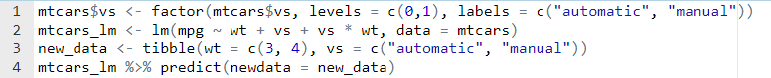

Line 1: Converts the vs variable into a factor. The variable initial has values of 0 and 1. The factor levels are converted into “automatic” and “manual”.  
Line 2: Creates a linear model object called mtcars_lm. This is the result of a linear regression with mpg as the response variable and weight (wt) and transmition (vs) as the explanatory or predictor variables. The vs * wt is an interaction. The form of the explanatory variables in this model give automatic and manual transmissions unique and separate slopes and intercepts.  
Line 3: Creates a new tibble called new_data that includes the values for wt and vs that we will use to predict a value for the mpg of the car. We have two different cars. The first has a weight of 3 and has an automatic transmission. The second one has a weight of 4 and has a manual transmission.  
Line 4: Uses the mtcars_lm model and the new_data tibble to predict the mpg for the two cars. Predict substitutes the values for wt and vs into the estimated equation.

Code Chunk III: Transformations using dplyr

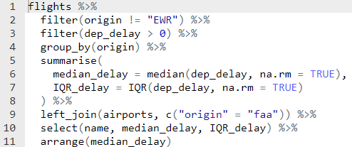  
  
Lines 1 – 2: Chooses all of the rows from the flights tibble that don’t originate from Newark (EWR)  
Line 3: Chooses only those observations that are delayed.  
Line 4: Groups the observations into categories defined by origin (JFK and LGA)  
Lines 5 – 8: Calculates the median and interquartile range for JFK and LGA. The result is a tibble that has origin airport as its rows and median_delay and IQR_delay as columns  
Line 9: Adds information from the airports tibble to the tibble that has been created in lines 1 through 8. The primary key from the created tibble is origin and the foreign key from the airports tibble is faa  
Line 10: Selects the columns name, median_delay, and IQR_delay   
Line 11: Sorts the rows of the resulting tibble by median_delay from smallest to largest

Code Chunk IV: Functions and Iteration

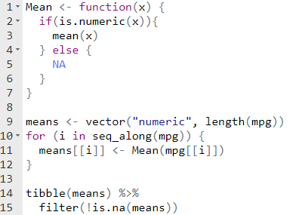

Line 1: Names the function and identifies x as its argument  
Lines 2 – 7: This if else structure first tests to see if x is numeric. If it is numeric then it calculates and returns the mean. If x is not numeric, then the function assigns the value as missing and returns an NA value.  
Line 9: Initializes a numeric atomic vector called means. Its length is the number of columns in the mpg tibble.  
Line 10: Sets up a for loop. The index variable I takes on the values between 1 and the number of columns in mpg.  
Lines 11 – 12: Assigns the result of our applying our Mean function to each column in the mpg tibble. The result is put into the ith slot of the vector that we created in line 9.  
Line 14: Created a tibble from the means vector that was initialized in line 9 and calculated in line 11.  
Line 15: Removes the missing observations from the tibble

Code Chunk V: Communication Graphics

The presidential tibble has four variables initially:

* name of president
* start date of administration
* end date of administration
* political party

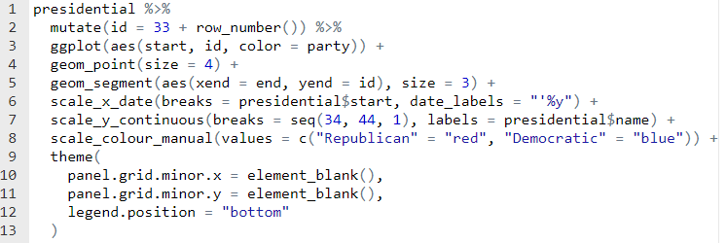

Lines 1 – 2: Calculates a new variable called id by adding the row number of each observation to 33. This gives the number of the president administration.  
Line 3: Assigns x as the date of the start of the administration and y as the id created in the previous step. Color is scaled or assigned to the political party.  
Line 4: Created a scatter plot where each point has a size of 4.  
Line 5: Geom_segment requires an x and y value for the start and an x and y value for the end of the line segment. In this case, it gets the start x and y from the aes declaration in the ggplot call. The aes in the geom_segment specifies the ending x and y values. They are the end variable and the id variable.  
Line 6: Specifies that the x axis is a date and the tick marks appear at the start of each president’s administration. The format of the data is an apostrophe by the last two digits of the year.  
Line 7: Creates tick marks at the integers between 34 and 44 and then labels the tick marks by the president’s name.  
Line 8: Defines that the color which was assigned in line 3 should be red for Republican and blue for democrat.  
Lines 10 – 11: Excludes the minor grids for the x and y axes  
Line 12: Positions the legend at the